**ITS290F**

**Human Computer Interaction&**

**User Experience Design**

**Take-home Assignment**

**Jiawei Wang**

**S1239587**

**May 2021**

**Table of Contents**

**1. Introduction ………………………………. 3**

**2. Analysis ……………………………………… 6**

**3. Suggestion ………………………………… 21**

**4. Conclusion ………………………………... 27**

**5. Reference …………………………………. 28**

**1. Introduction**

**In this semester, I learned a lot about how to design a user-friendly website ---- not just how to build a website.**

**Nowadays, as the development of browser and some techniques, there are many tools that can help us build a website. In some fields, program can build a website automatically, even though its designer does not know much about computer.**

**We should admit that ---- the cost of building a website has been reduced. But relatively, the importance of a good website has increased dramatically. It is very important to learn something about how to design a user-friendly and efficient website.**

**In this Assignment, I will introduce two websites:**

[**https://codeforces.com/contests**](https://codeforces.com/contests)

[**https://angold4.com/**](https://angold4.com/)

**Both are the website that I frequently visited. And I will use these two different websites as an example to analysis them and then introduce some techniques that I’ve learned from this course.**

[**Codeforces**](https://codeforces.com/contests)

**[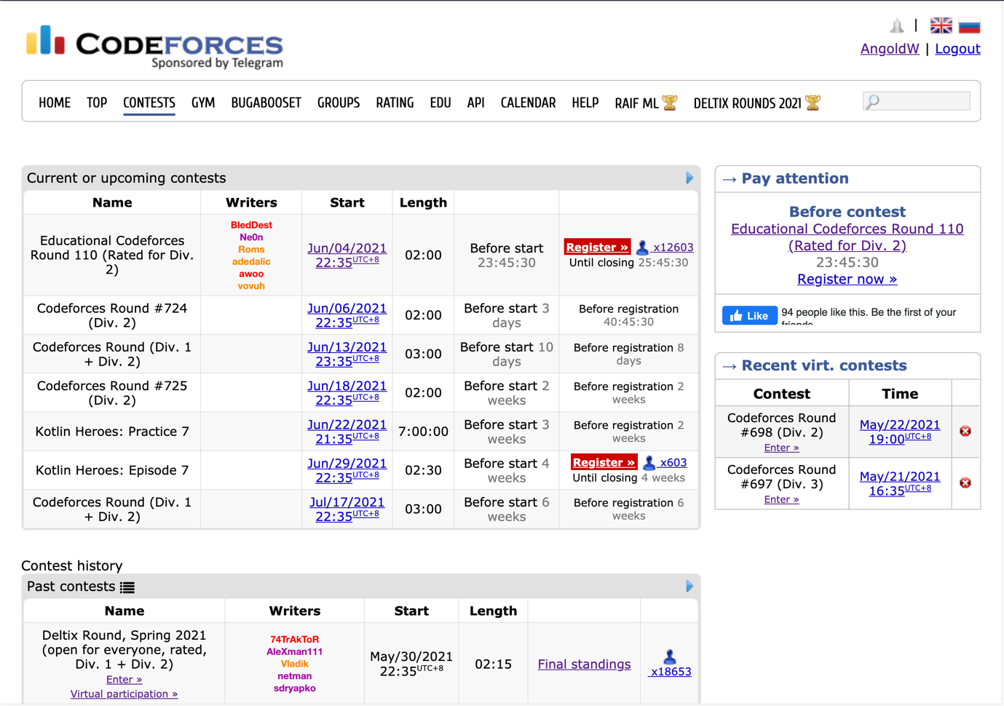](https://codeforces.com/contests)**

**The Codeforces website gave me a very nice user-experience when I try to find contests there.**

**As you can see in this contests index page, you can find the Current or upcoming contests and Contest history quickly. Since they are arranged very neatly according to the format.**

**Because of the table and some hyperlinks in right positions, you won’t feel so tired when you check or seek the information there.**

[**angold4.com – Angold Dmitry’s Blog**](https://angold4.com/)

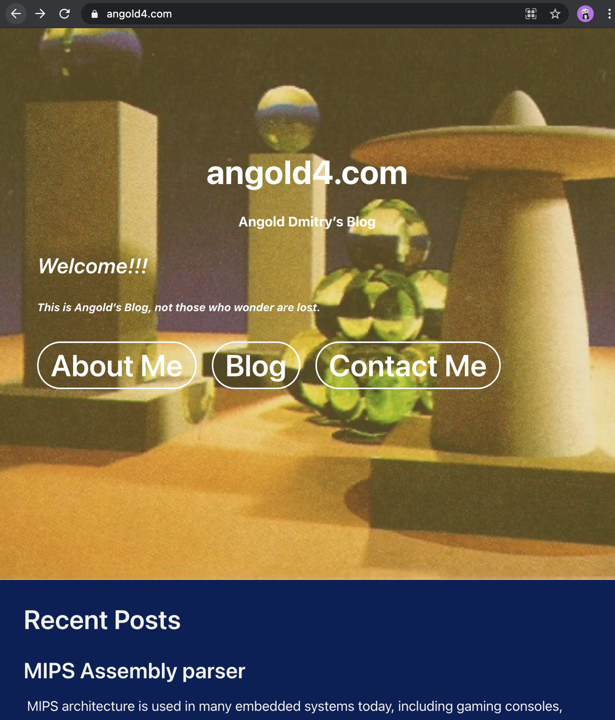

**But every time when I try to learn something in angold’s -blog (He’s blog teaches people about the JavaScript, which is very useful for beginners like me).**

**Every time I access it, I am just felt so weird. Since some of the features are not so friendly to use, and I always get lost at the pages that cannot find the materials I want. I may try to analysis it and then fix it using the techs I’ve learned from this course.**

**2. Analysis**

**First, I’d like to modify two common users’ journey in these two sites, and describe their user persona:**

**1. Carl Johnson**



**Personas:**

**This guy named Carl Johnson – a 24-year-old unemployed living in Liberty City.**

**One day he heard from his friend Lance Wilson who worked in an IT company and tell him that “If you want to make money. Just try to learn something about IT, and then it is easy for you to get a job with high salary.” And recommend** [**angold4.com**](https://angold4.com/) **to him as a beginner learning website.**

**Journey:**

**1. When he accesses the index page of the website. He finds that there are so many words in that index page, that he cannot find where the beginner guide is. And the most important thing is – he cannot find which button can be clicked (because they are too similar)**

**2. After having a call with lance and then he opens the right page (** [**Sigreturn Oriented Programming Attack**](https://angold4.com/2021/02/01/sigreturn-oriented-programming-attack/) **)**

**3. After having a nice learing journey, he found some questions that want to asked to the author of this article, Mr.Angold Dmitry. Then he open the** [**contact page**](https://angold4.com/contact/) **( which also take he so much to find it )**

**4. But after he slowly input the name, age, e-mail, and birthday then press submit. But then there is no action in that page that tells him the successful submission.**

**5. Another problem is that Carl makes a slip – he forgets to add ‘@’ in his e-mail. But the form system did not alert him about this tiny slip.**

**6. 5 days later, Carl still not receives the reply of Angold – Angold doesn’t know about his e-mail.**

**Then Carl just gives up – too hard for him to learn.**

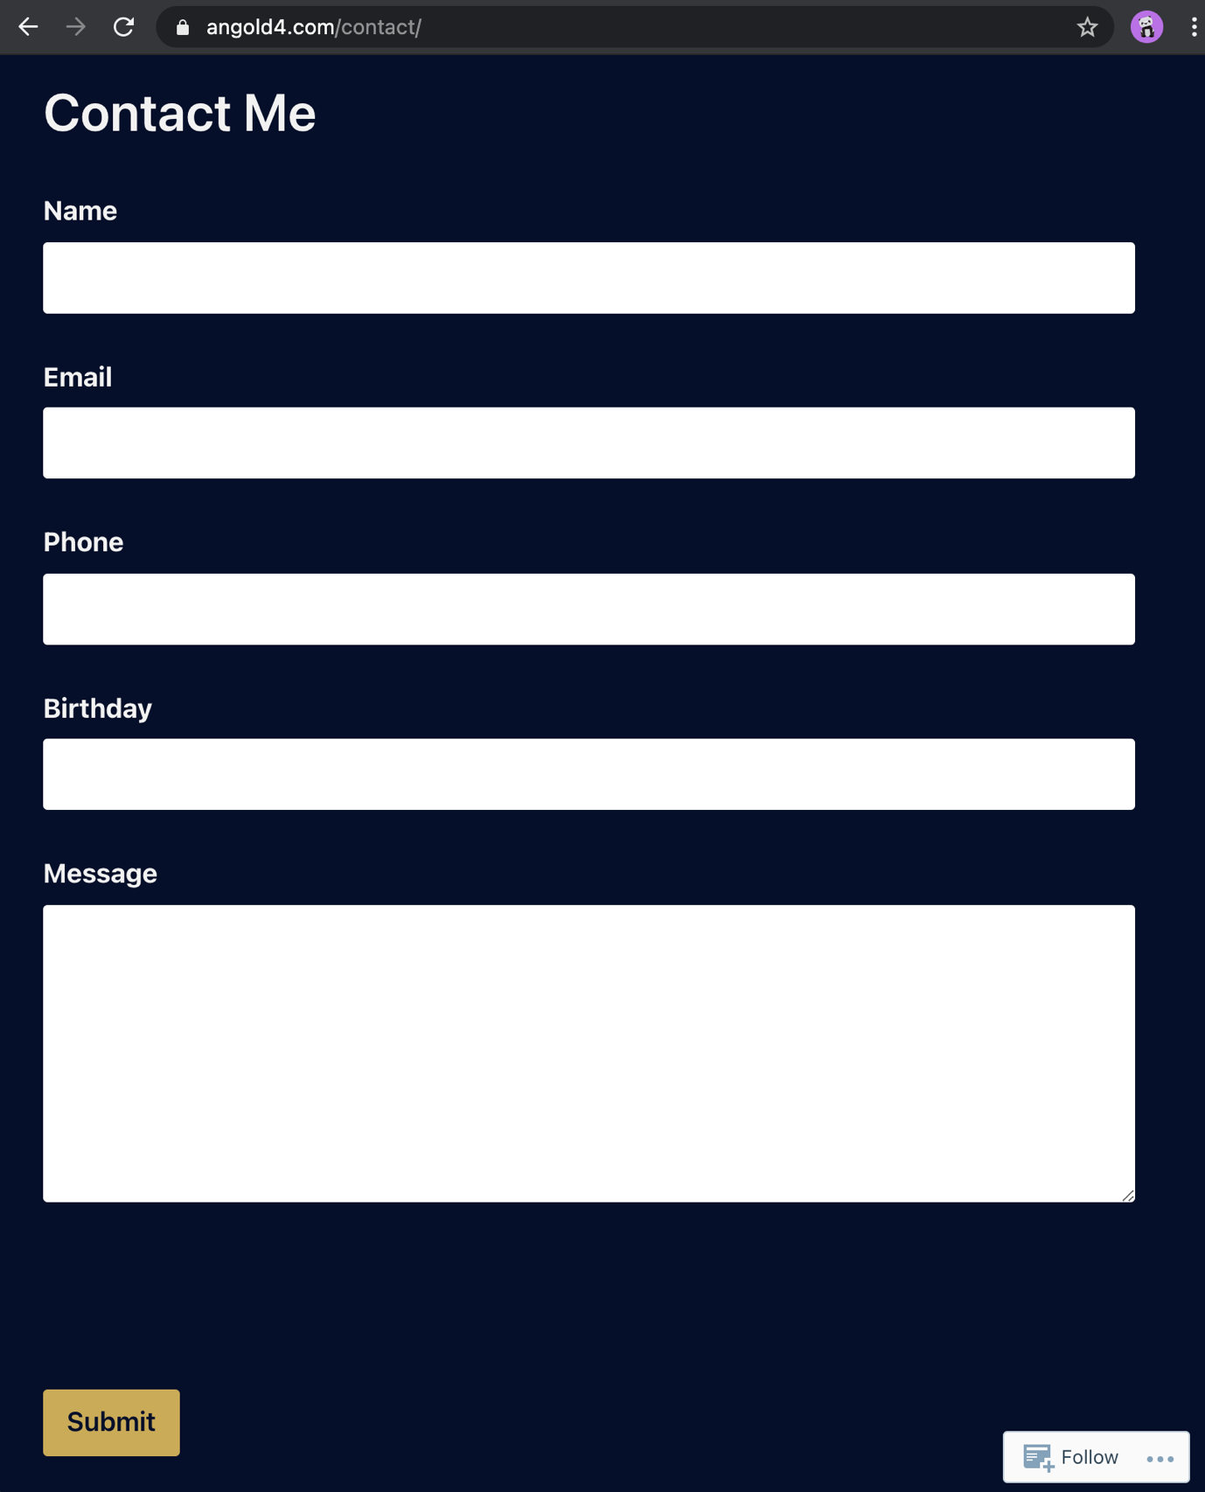

**2. Melvin Harris (Benq)**



**Personas:**

**Melvin Harris is a graduate student at UCSB who received Ph.D. degree last year. And he is also a famous competitive programmer in** [**Codeforces**](https://codeforces.com/profile/Benq)**. Named “Benq”.**

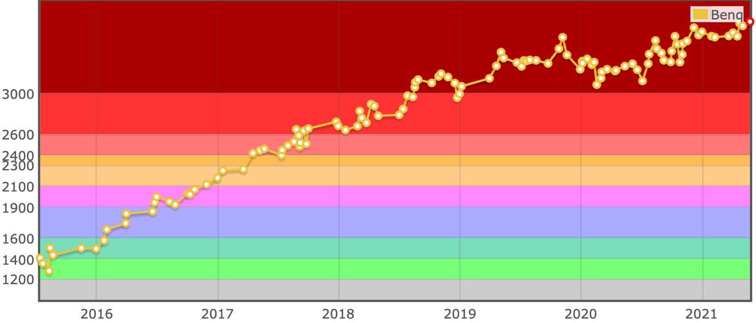

**Journey:**

**1. Since Harris also has a full-time job, he cannot login to Codeforces any moment he wants. But he wants to attend all contests that were irregularly being held to keep his high ratings.**

**2. He loves Codeforces not only because the friendly people there and challenging contests, but also the brilliant and user-friendly clean web page.**

**3. Every time he has time to check the contests, he will just open** [**https://codeforces.com/contests**](https://codeforces.com/contests)**. – This clean and tiny webpage will show him the upcoming contests with the countdown time. Also, if he wants, he can check how many competitors he has and whether his friends come to this contest.**

**4. He can also find the contests he missed recently easily – just by seeking below the upcoming contests. And consider making a virtual participation.**

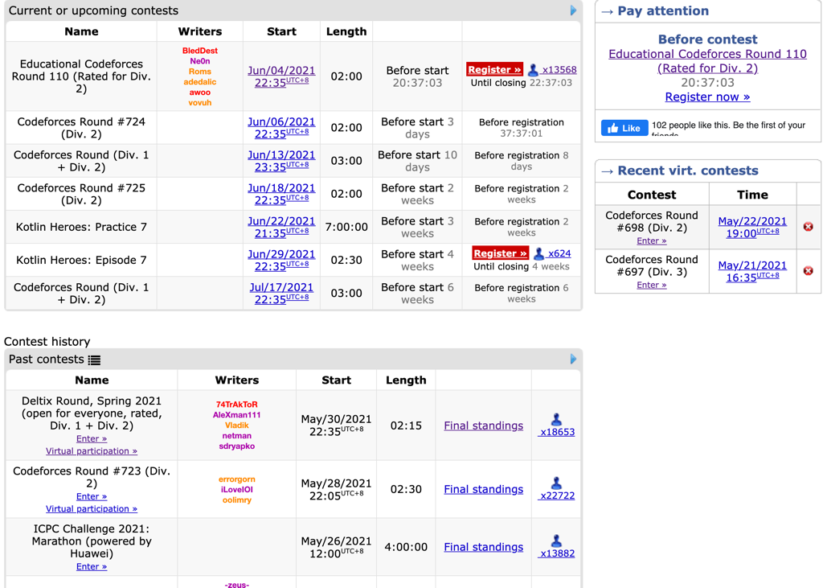

**Then, I’ll analysis these two websites respectively. By using the UI design guidelines and principles I’ve learnt from this course:**

***1. Visibility of system status:***

**In Codeforces, users will always be informed of system status, these two screenshots below shows once a user register an upcoming contest. The red “Register” button will become green with text “Registration completed”. Which will give users clear feedback about what they’ve done in this website. And what will happened in the future.**

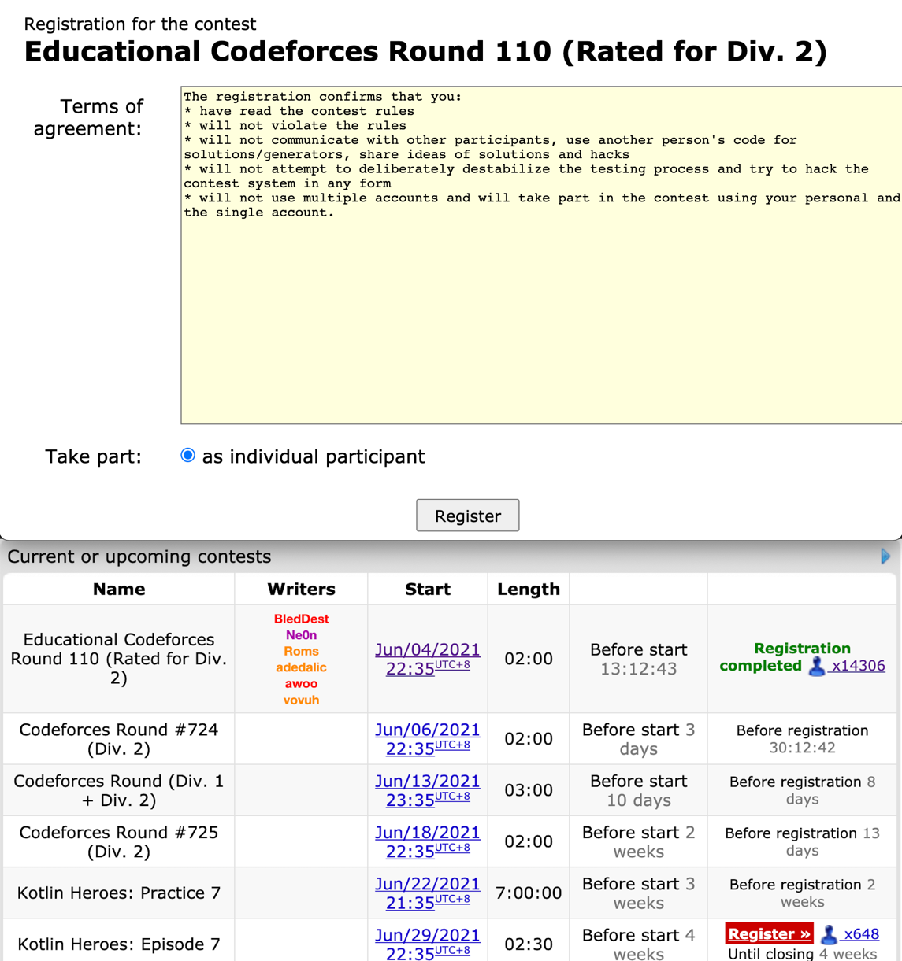

**But in angold4.com, when you try to contact Dmitry through the “Contact Me” page, after click “submit”, like the things happened with Carl Johnson, we won’t receive the feedback about whether the messages have been sent successfully.**

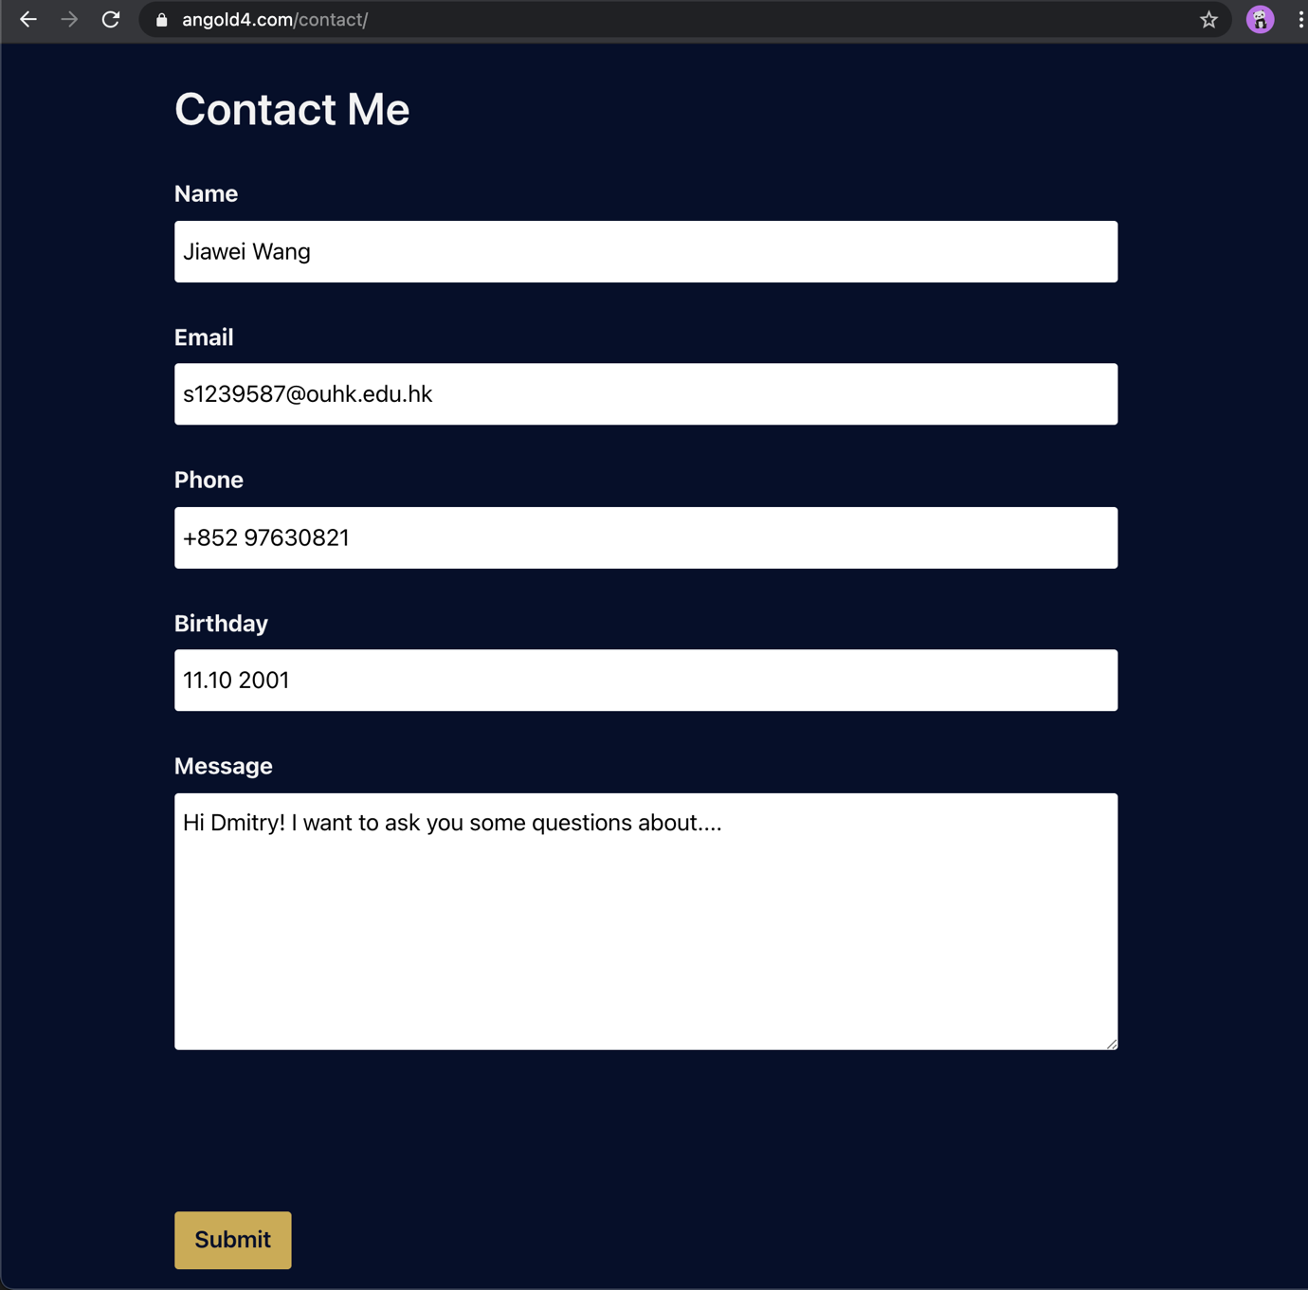

***2. Consistency and standards:***

**The interfaces of Codeforces use the same style, as we can see in these two figures below: you will always find register button at the top right corner, and same style toolbar every page with same options.**

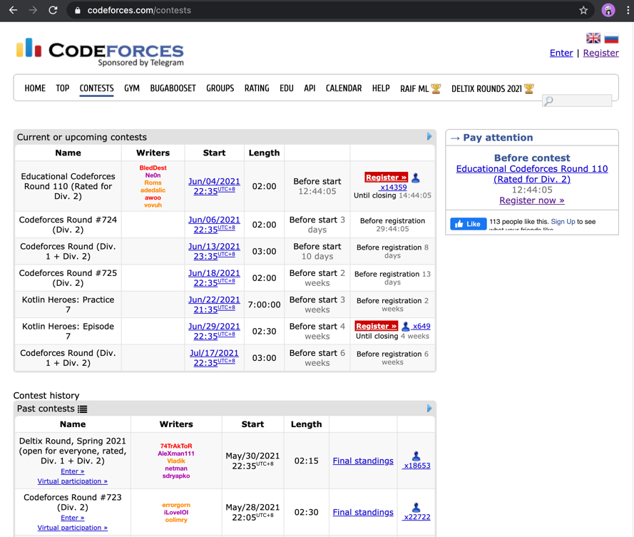

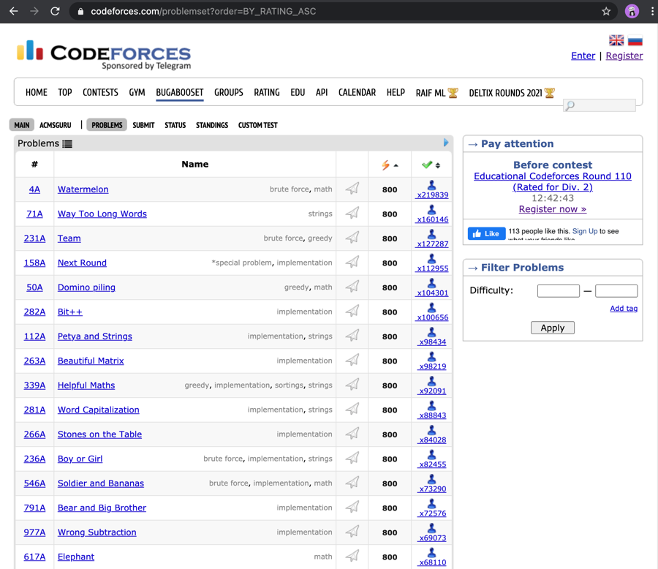

**Things are different in angold4.com, the layout of index page and other pages are different.**



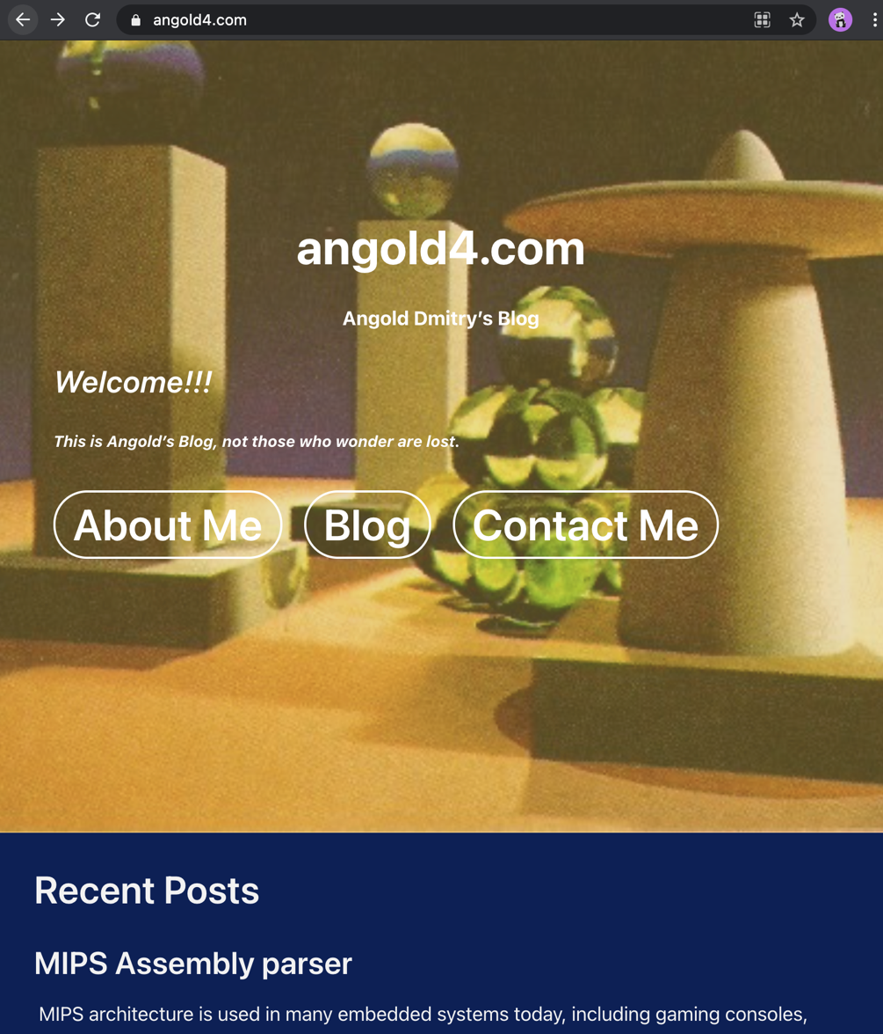

***3. Aesthetic and minimaist design***

**In** [**contest**](https://codeforces.com/contests) **page of codeforce. There only have necessary components for the current tasks. Like contests name, writers, start, length and upcoming time. All things that are unnessary or unimportant are ignore or uses hyperlink. Like the global timezone, final standings of the history contests.**

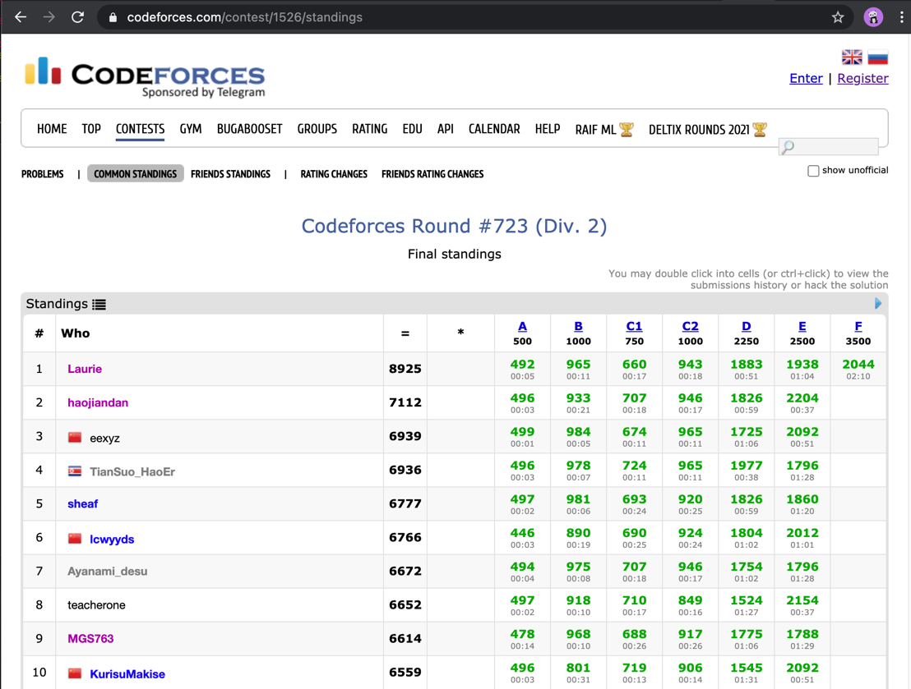

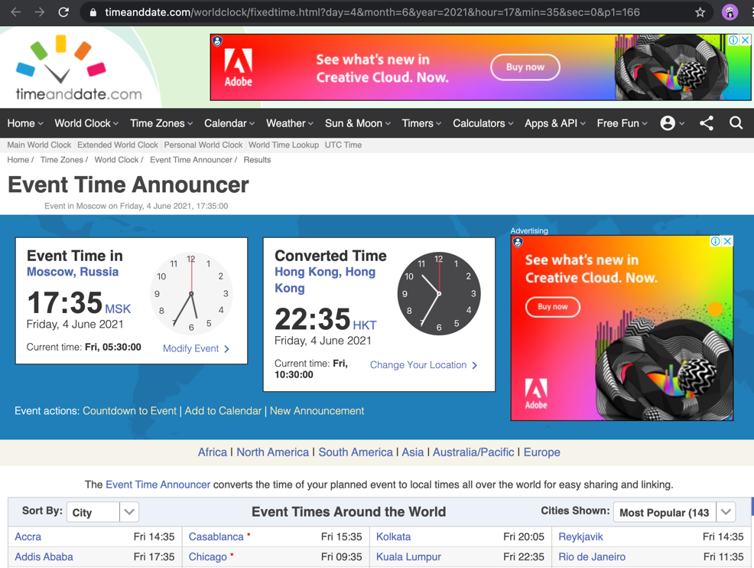

**When a user come to angold4.com at the first time, there are so many things layout in the page, and it is hard for them to find the target they want in this site.**

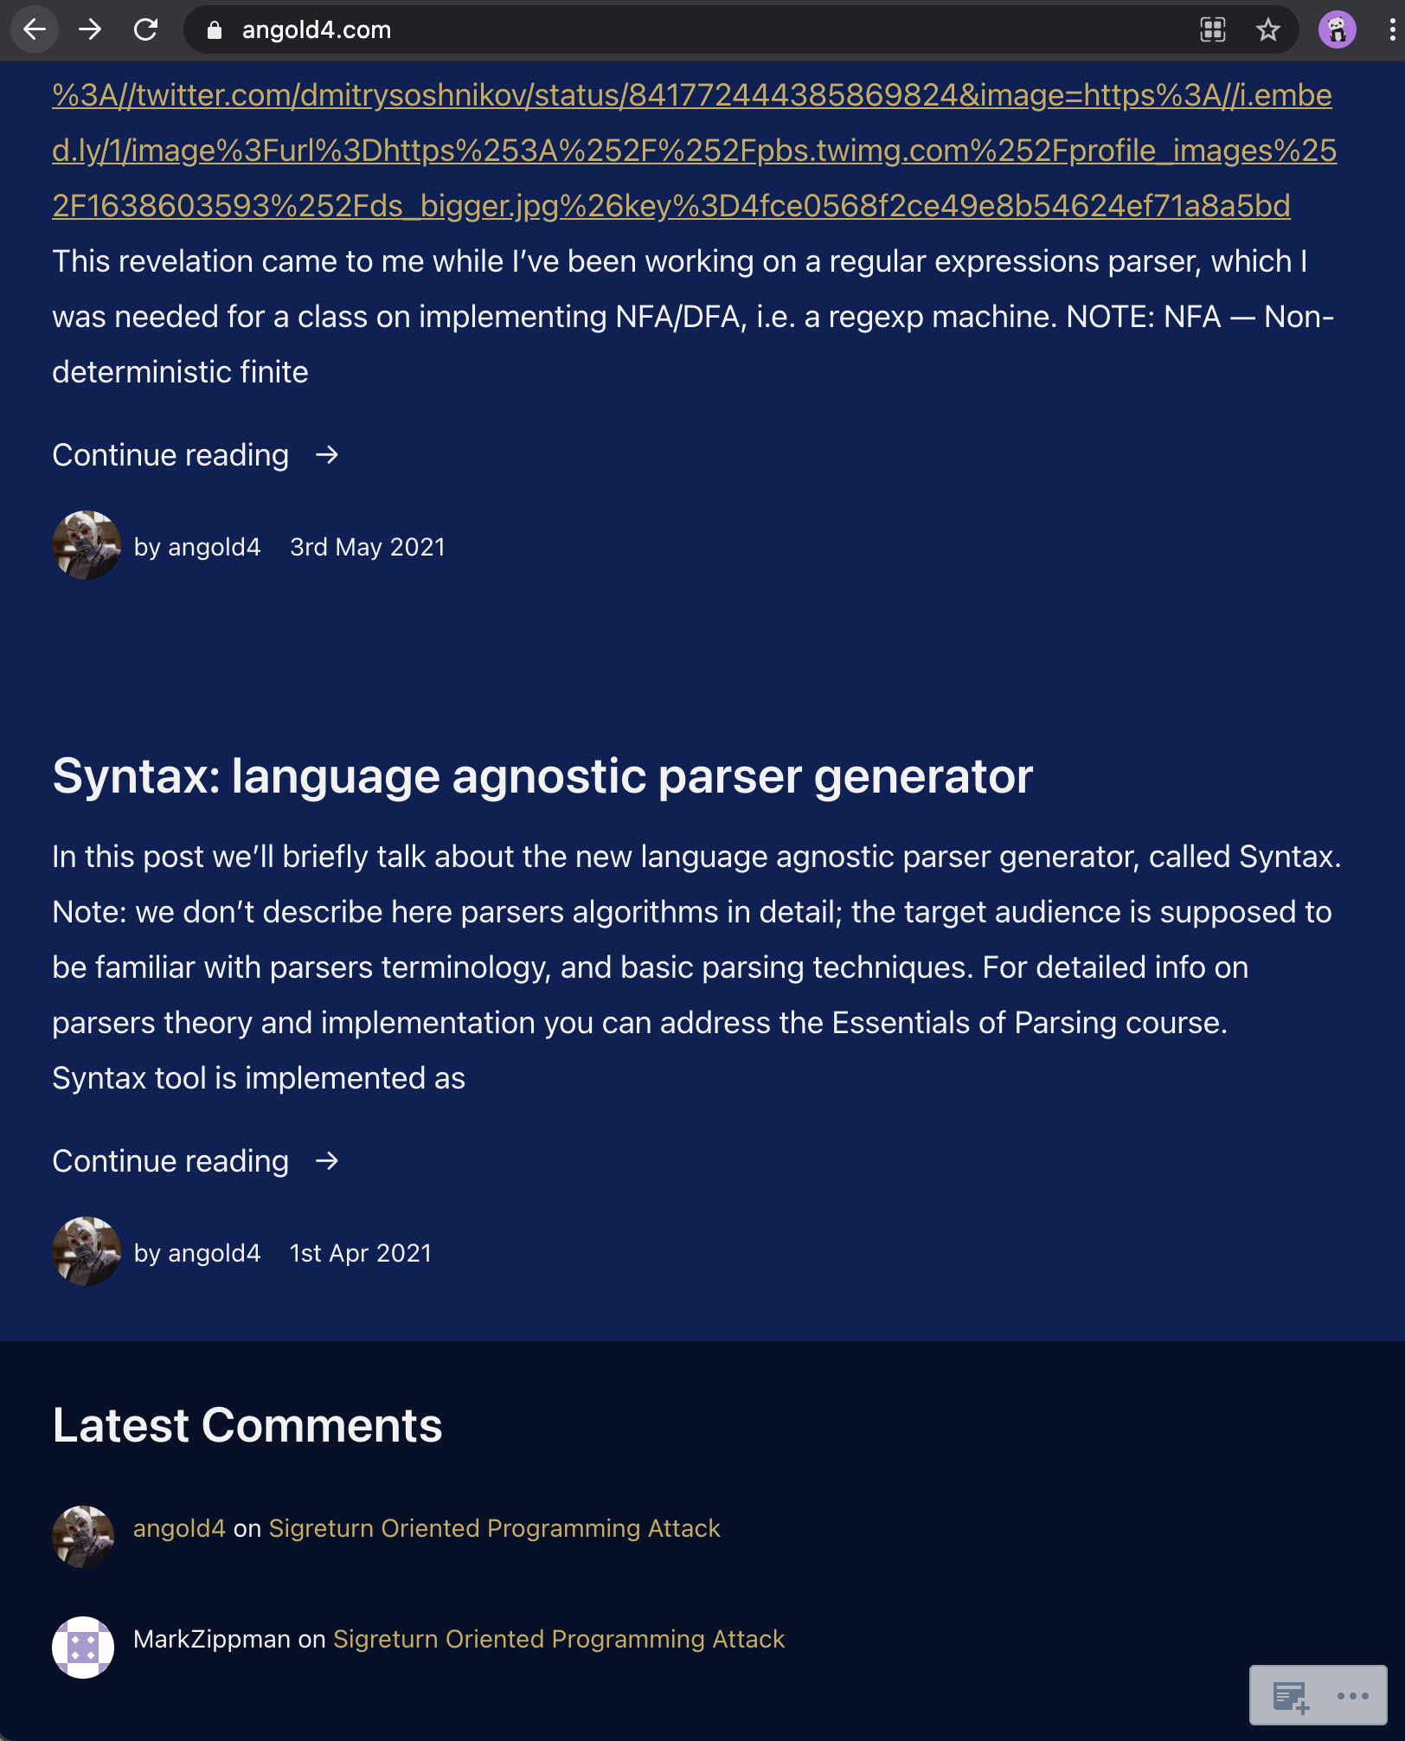

***4. Strive for consistency***

**In Codeforces, the buttons or links which can be entered are easy to find with description. With the same consistent color, layout, capitalization, and fonts. Which are easy to use and enter the user’s want functions.**

**In angold’s** [**index**](https://angold4.com/) **page. The three buttons: “About Me”, “Blog”, “Contact Me”, are not so obviously to be found – Since they have the same color with the simple text and don’t like the normal buttons**

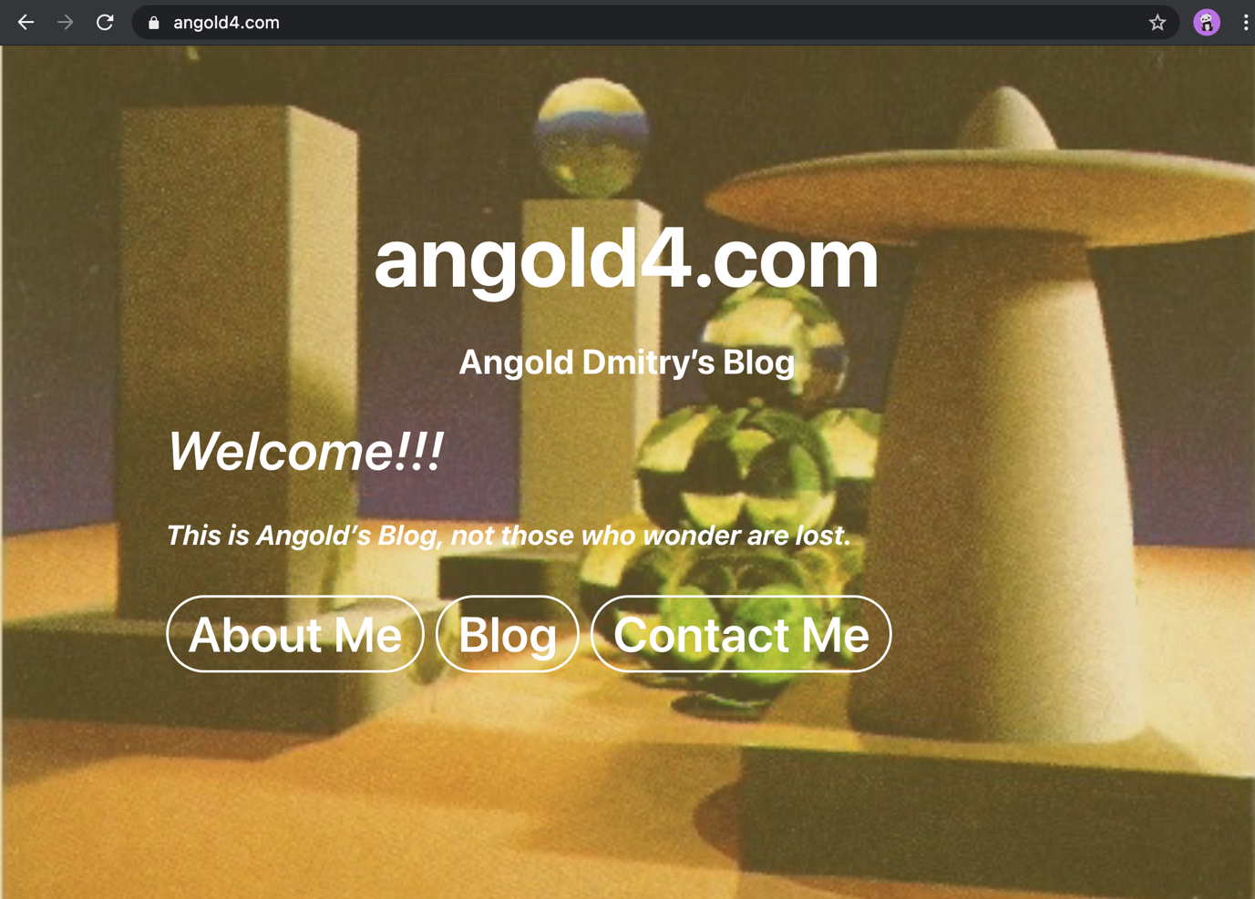

***5. Prevent errors and help users recognize, diagnose, and recover from error.***

**When you want to register in Codeforces and just input invalid E-mail address or repeat username. The site will flagging actions that may result in errors:**

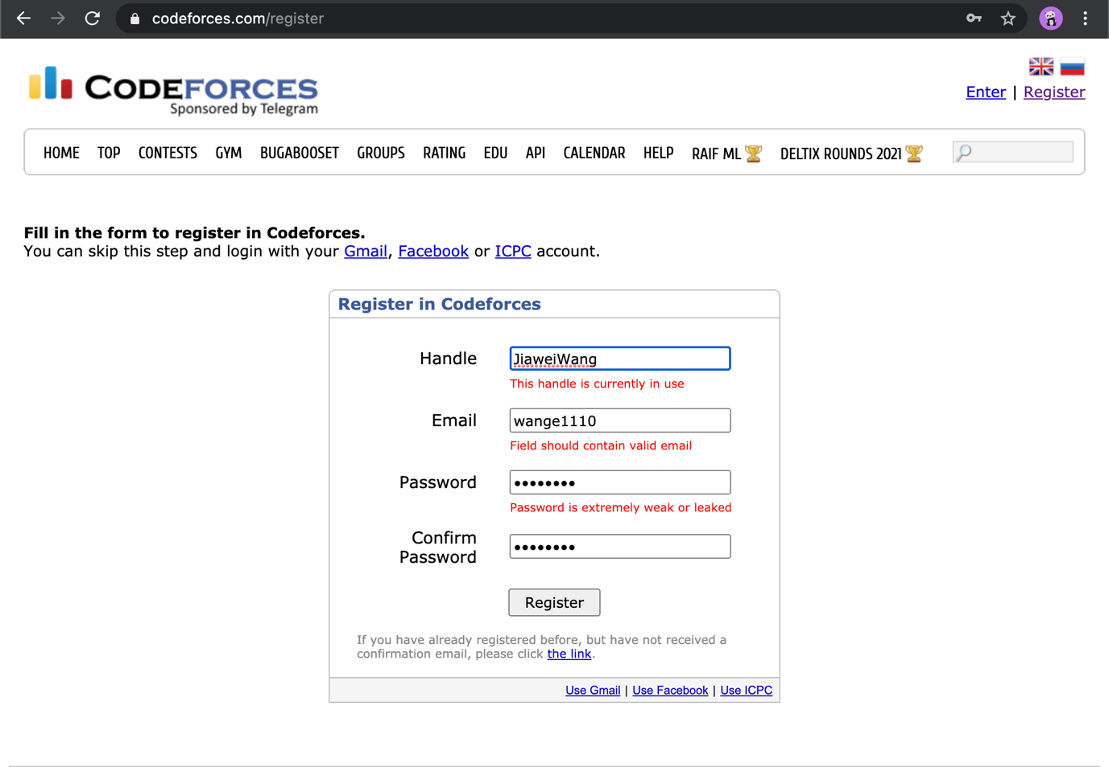

**But like the case with Carl Johnson. Even if he submits the message successfully. But maybe because of some tiny slips that unnoticed – like submit the wrong format e-mail address. There won’t have any alerts.**

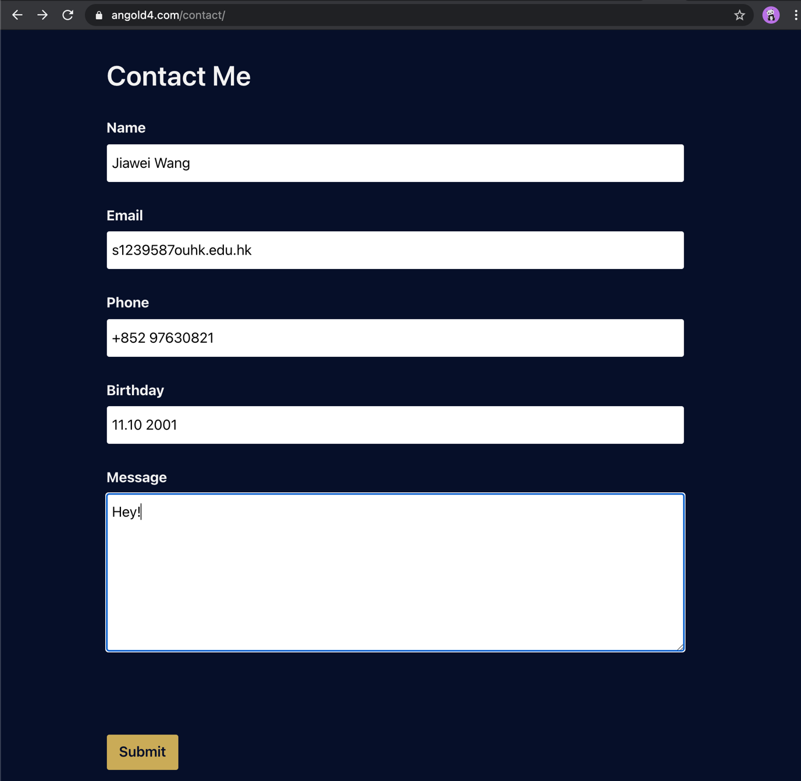

**3. Suggestion**

**In this stage, I will give the solution and the implementation of the optimized** [**angold4.com**](https://angold4.com/) **using the techs I’ve learnt in this semester.**

**1. Visibility of system status:**

**To display the status, and let user know that he is submit the form successfully. After the user press “Submit”, there will be an alert event that tells that Submit successfully.**

**(Please check Contact.html)**

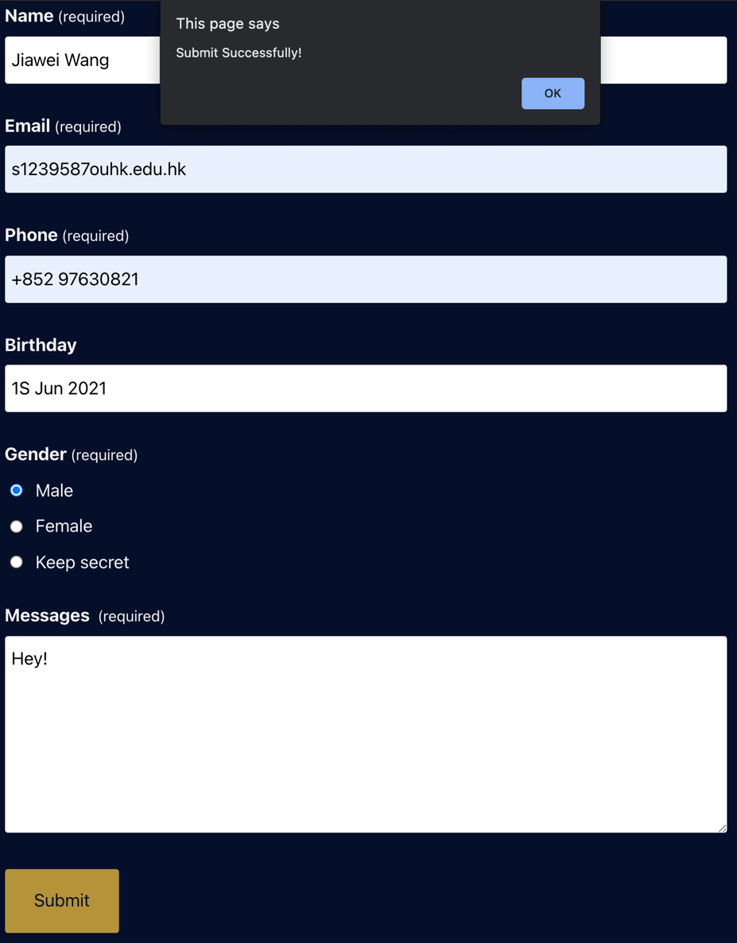

**2. Consistency and Standards**

**I adjust the index page, to make it much consistent as other pages. By adding toolbar there. Which can help users find the things they want quickly.**

**(Please Check Index.html)**

**Before:**



**After:**

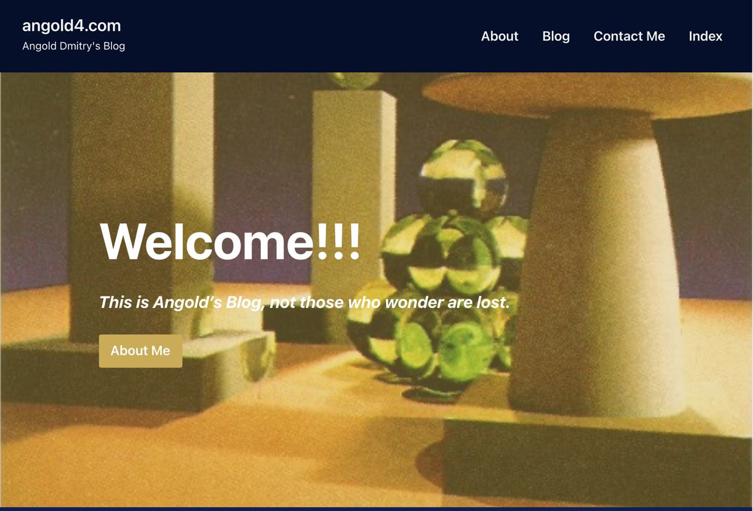

**3. Aesthetic and minimaist design**

**In the index page, I use few hyperlinks instead of the contents of the articles to display the recent posts. Which can give user a clean experience and help them find the article they want quickly.**

**(Please check Index.html)**

**Also, I add the details of the comments to display the important things.**

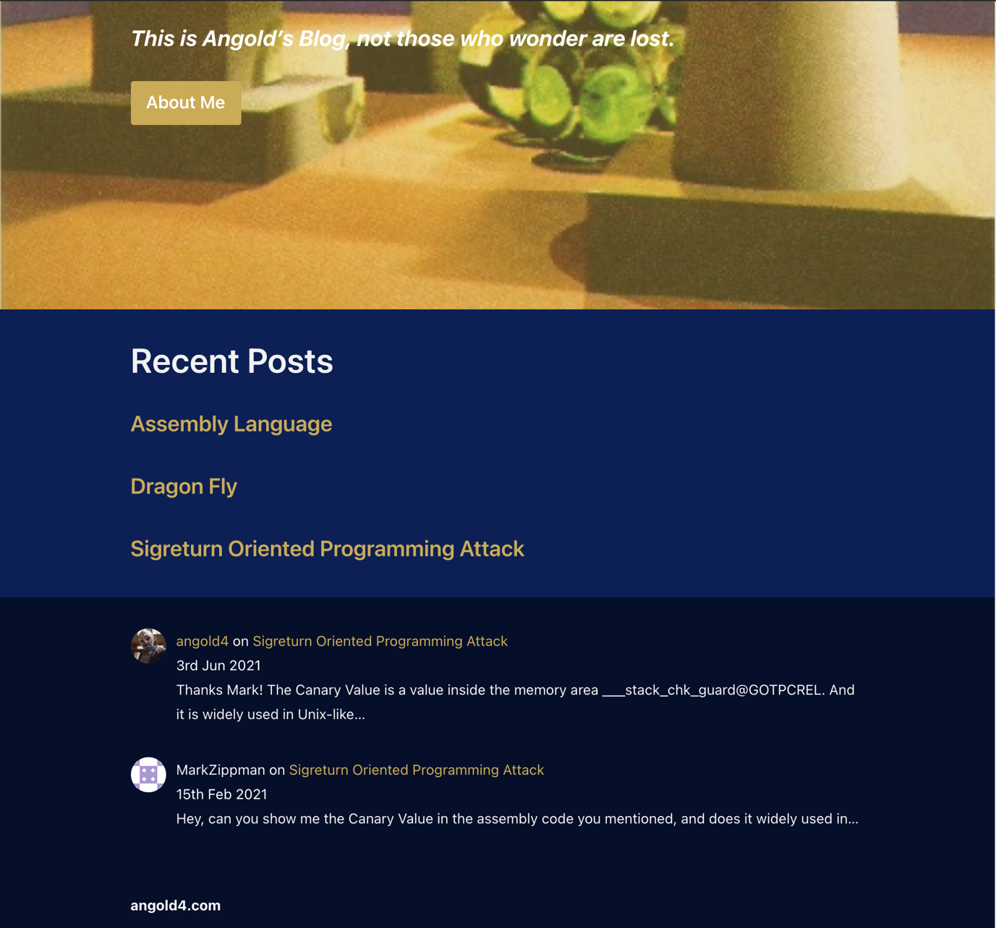

**4. Strive for consistency**

**For that: I use different colors to distinguish the Hyperlink and the normal text. And make the Button “About Me” more like a “Button”.**

**Before**



**After**



**Before**



**After**



**5.help users recognize, diagnose, and recover from error.**

**I use react and Bootstrap to implements the format-checking system; If you do not fill the (required) contents, The Page will also give an alert:**

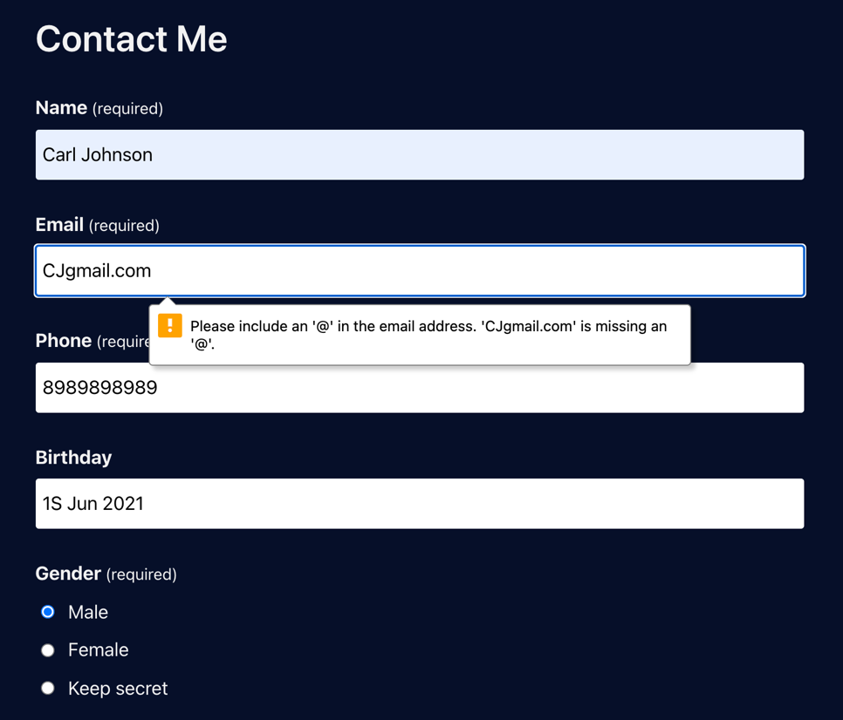

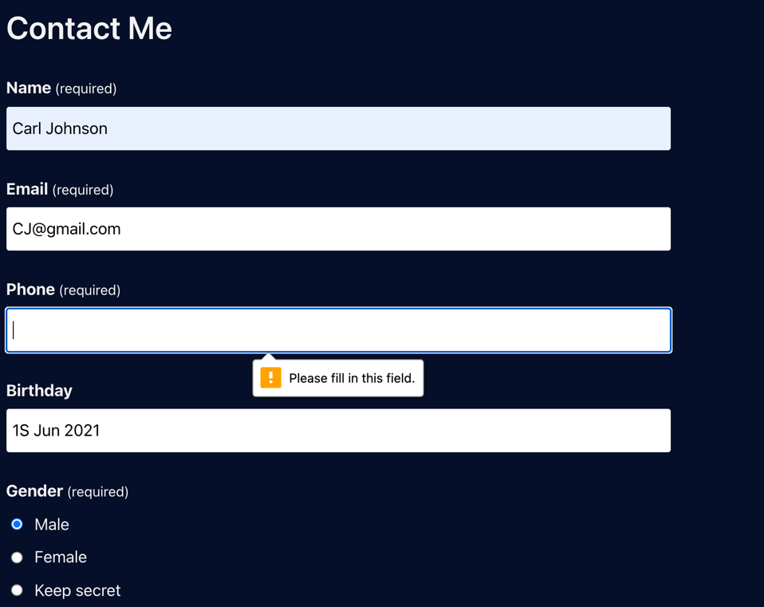

**Finally, I add a calendar to help users input their birthday faster. And more directly.**

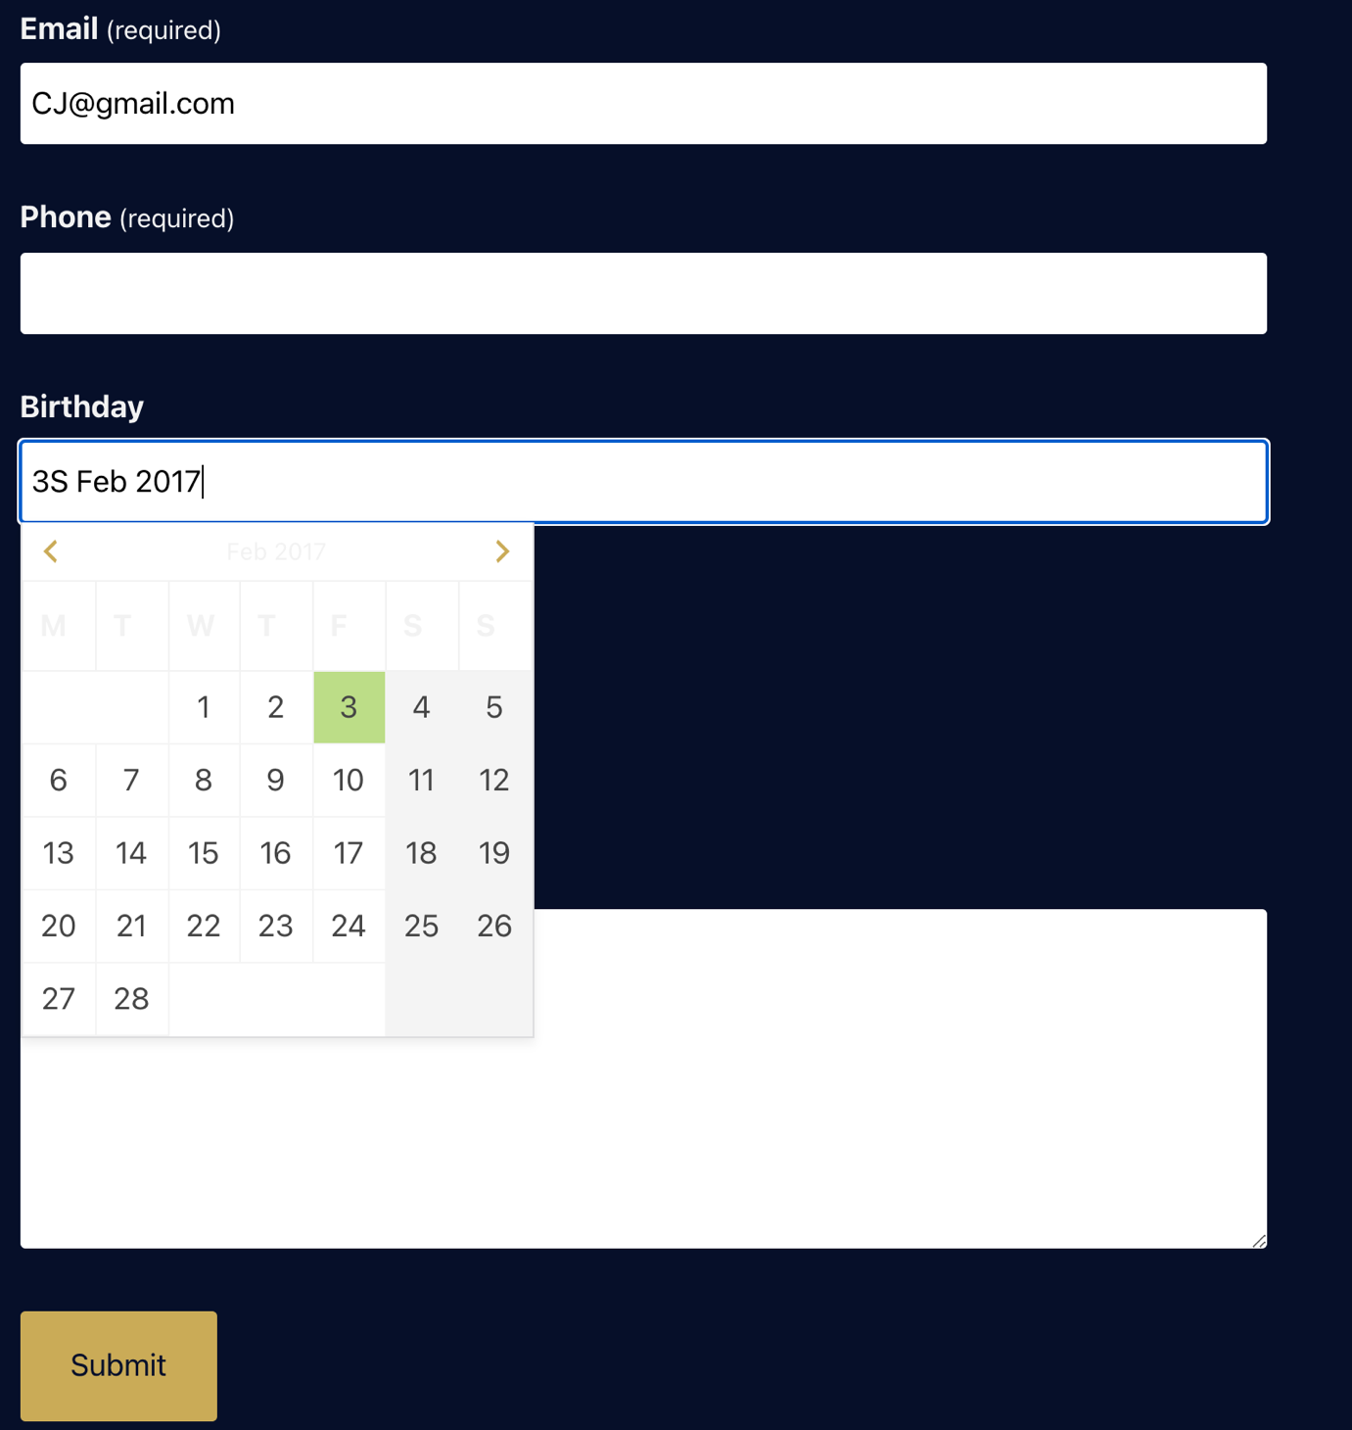

**4. Conclusion**

**During this assignment, things are harder than I expected – In the origin source webpage code, there are a lot of new things and new features that I do not know before. And every time I am just searching it using google, trying to know its usage and help me to optimize the webpage.**

**Maybe there are some bugs in the final webpage I submitted. Also, there are many lines in the source code I still do not understand its usage.**

**I believe that the things I’ve learnt from this course are the most important thing – the rules to design a user-friendly website. The way to build a website may change. But the ideas behind it are more valuable.**

**Thanks to Dr. Tang and Mr. Tommy.**

**Reference:**

[**http://www.cs.umd.edu/~ben/goldenrules.html**](http://www.cs.umd.edu/~ben/goldenrules.html)

[**https://www.interaction-design.org/literature/article/user-interface-design-guidelines-10-rules-of-thumb**](https://www.interaction-design.org/literature/article/user-interface-design-guidelines-10-rules-of-thumb)

[**https://developer.wordpress.org/**](https://developer.wordpress.org/)

[**https://getbootstrap.com/docs/5.0/getting-started/introduction/**](https://getbootstrap.com/docs/5.0/getting-started/introduction/)

[**https://reactjs.org/docs/getting-started.html**](https://reactjs.org/docs/getting-started.html)